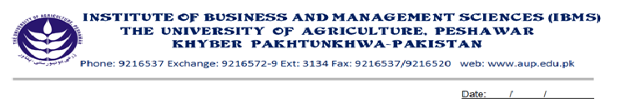

**Program: BS (IT) - I**

**Course Name: English Composition & Comprehension**

**Course Code: EG- 301**

**Session: 2012-2015**

**Credit Hours: 03**

**Total weeks: 16-18**

**Total Hours: 48-54**

**Course Objectives:**

This course has been designed to introduce and enhance the basic grammatical concepts of the English Language. Students in this course will learn to improve their basic and fundamental writing, reading and speaking skills. The main emphasis will be to help them to use the English language correctly in their Business Administration field for which English language competency is a prerequisite.

* **Week-1** Sentence & Sentence Structure

Subject, Predicate

Phrase, clause

Kinds of sentences

* **Week-2**

Noun and Kinds of noun

Noun case,

Noun clause, noun phrase

Pronoun

Articles

* **Week-3** Verb

Kinds of verb:lexical/auxiliary

Transitive/ Intransitive, Regular/ Irregular, Gerund/ Infinitive

* **Week-4**

Forms of verb

Subject-verb agreement

* **Week-5**

Adverb & kinds of adverb

Formation of adverb

Use of adverb

Degree of adverb

Adverb clause & phrase

* **Week-6**

Adjective, Kinds of adjective

Composition of adjective

Adjective clause and phrase

Degree of adjective

* **Week-7**

Preposition, kinds, usage

Conjunction

Interjection

* **Week-8**Punctuation

Spellings Rules

Vocabulary

* **Week-9** Introduction to Tense Structure

Present Simple Tense

Past Simple Tense

Future Simple Tense

# Week-10

Present Continuous Tense

Past Continuous Tense

Future Continuous Tense

* **Week-11**

Present Perfect Tense

Past perfect Tense

Future Perfect Tense

* **Week-12** Present Perfect Continuous Tense

Past Perfect Continuous Tense

Future Perfect Continuous Tense

* **Week-13**

Active & Passive Voice

Use & Rules regulation

* **Week-14**

Active & Passive Voice

Use & Rules regulation

* **Week-15** Direct & Indirect Narration

Use & Rules regulation

* **Week-16** Direct & Indirect Narration

Use & Rules regulation

**Recommended Books:**

* **High School English Grammar and Composition. Wren and Mortin**
* **A functional Approach to Modern English Grammar. Green Baul**